

**University of Technology and Applied Sciences**

**Department of Engineering**

**Electrical and Electronics Engineering Section**

**Smart Electricity Management System**

**Semester 2**

**2023-2024**

**Diploma Second Year**

**Computer Engineering**

**Submitted by:**

1. **ID No.** 12S21200  **Name:** Fatma Hatem Mohamed Al-Sinawi
2. **ID No.** 16S2135966 **Name:** Anaum Ahmad Sana
3. **ID No.**12S21394 **Name:** Mowadah Abdullah Mohammed Al-Jabri
4. **ID No.**16J2020  **Name:** Hiba Said Hamood Al-Kuwaili

**DECLARATION**

We understand that all my/our project work must be our own unaided work. If we make use of material from any other sources, we must clearly identify it as such in any interviews, reports, or examinations. I/we understand that our reports must be written unaided in our own words, apart from any quoted material which we must identify clearly in the correct manner.

We understand that the work which we shall present for assessment must be, work carried out by ourselves only during the project period which has not been previously prepared. Where any such previous work is made use of in the project, we shall make this clear in any interviews, reports or examinations.

****We understand that violation of these conditions may result in a mark of zero for the component or components of assessed work affected.

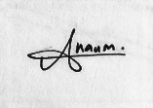**Student Name:** Fatma Hatem Al-Sinawi **ID:** 12S21200 **Signature:**

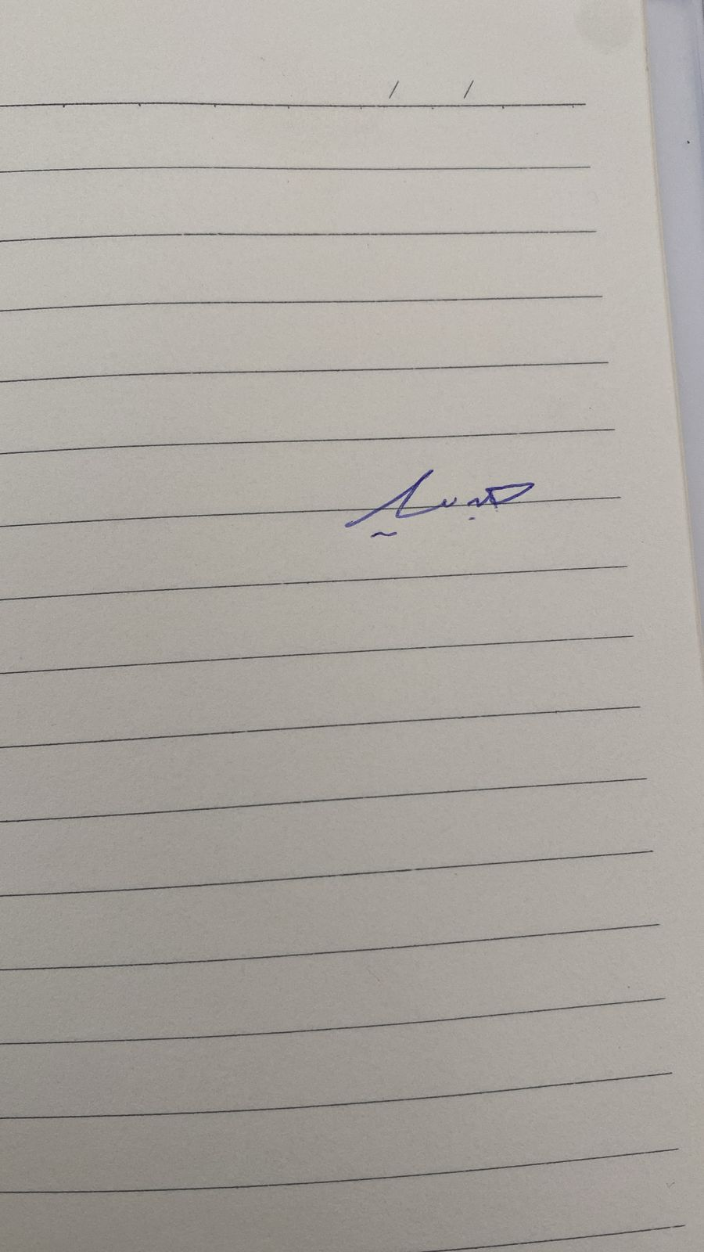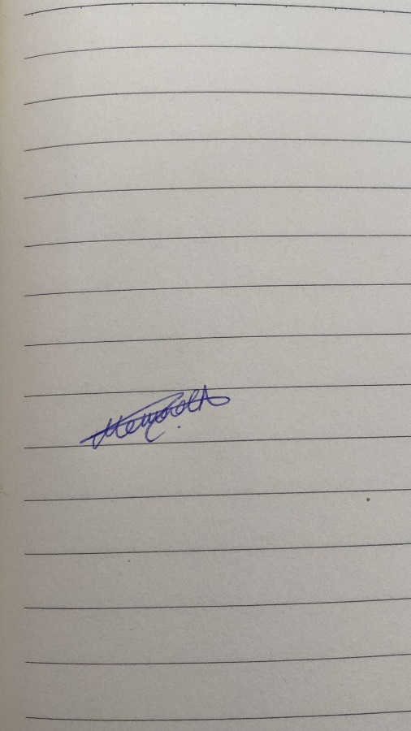**Student Name:** Anaum Ahmad Sana **ID:** 16S2135966 **Signature:**

**Student Name:** Mowadah Abdullah Al-Jabri **ID:** 12S21394  **Signature:**

**Student Name:**Hiba Said Al-Kuwaili **ID:** 16J2020  **Signature:**

# 

**Supervisor Name:** Rashid Abdullah Ali Al Shehhi

**Date of submission:** 14/05/2024

**CERTIFICATE**

This is to Certify that the Project titled “Smart Electricity Management System” is the bonafide record of work done by Fatma Hatem Mohamed Al-Sinawi,Anaum Ahmad Sana, Mowadah Abdullah Mohammed Al-Jabri and Hiba Said Hamood Al-Kuwaili and submitted as a partial requirement for the completion of <Diploma Second Year> (**Bachelor / Advanced Diploma / Diploma**) in <Computer Engineering> in the Semester Fall of Academic Year 2023 - 2024

Supervisor Name: Rashid Abdullah Ali Al Shehhi

Supervisor Signature: Rashid Abdullah Ali Al Shehhi

Panel Members:

Sl. No. Name Signature

1.

2.

3.

4.

# **Acknowledgement**

We would like to thank our supervisor Mr. Rashid Abdullah Ali Al Shehhi for helping us with our difficulties and guiding us. We would also like to thank Mr. Ibrahim Said Nasser AL Yahmadi for helping us in our circuit. Next, we would like to express gratitude to Ms. Amelita Agotu Abriol for helping us in printing the PCB circuit board. We would also like to thank Mr. Reynaldo Cruz for helping in our circuit board.

# **Abstract**

This report explores the implementation of a smart electricity management system that integrates SMS and app features to enhance user control and efficiency in energy consumption. The system leverages advanced technologies such as Internet of Things to provide real-time monitoring, analysis, and control of electricity usage. By means of SMS notifications and an intuitive mobile application, customers can effortlessly monitor their energy usage, establish their preferences, and obtain notifications regarding possible energy-saving prospects. Users now have an easy and accessible way to actively regulate their electricity usage, which will ultimately enhance energy efficiency and save costs, due to the smart electricity management system's combination of SMS and smartphone capabilities.

**Table of Contents**

**Acknowledgement** 4

**Abstract** 5

**Chapter I** 10

**Introduction** 10

**1.1** **Background of the project** 11

**1.2 Statement of the Problem:** 12

**1.3 Objectives of the project** 12

**1.4 Scope and Limitation of the project** 12

**1.5 Significance of the project** 13

**1.6 Definition of terms** 14

**Chapter II** 15

**Review of Related Literature** 15

**2.1** **Local Similar Projects** 15

**2.2** **International Similar Projects** 17

**2.3** **Local Similar Products** 18

**2.4** **International** **Similar Products** 18

**Chapter III**-**Project Plan** 19

**3.1 Identification of Activities** 19

**3.2 Allocation of work** 20

**3.3 Project Timetable (Schedule)** 21

**Chapter IV** 23

**Project Design** 23

**4.1 System/Block diagram** 23

**4.2 Schematic diagram** 24

**4.3 System Flowchart** 25

**Chapter V** 25

**Simulation and Testing** 26

**5.1 Functions of Major Components** 26

**5.2 Functional Simulation** 29

**5.3 Actual Functional Test** 30

**5.4 Tabulation of actual and simulated outputs** 31

**Chapter VI** 32

**Results and Discussion** 32

**6.1 Findings** 32

**6.2 Graphical representation of results** 33

**6.3 Analysis of the results and discussion of findings** 34

**Chapter VII** 36

**Conclusion and Recommendation** 36

**7.1 Conclusion** 36

**7.2 Recommendation** 37

**References** 38

**Appendices** 38

**List of Figures/Diagrams**

**Figure 1: Project Timetable 19**

**Figure 2: Block Diagram 20**

**Figure 3: Schematic Diagram 21**

**Figure 4: System Flowchart 22**

**Figure 5: Graph of Results 29**

# **Chapter I**

## **Introduction**

Smart Electrical Management System (SEMS) is the result of integrating technology, such as application, interface and IoT sensors and devices, all calibrated to optimize energy use with efficiency.

Our project consists of an application that will allow users to be connected to the electronic devices in their homes. In this application, the users can set a limit for the amount of money they want to spend each month on electricity. According to that, the app will automatically set the time that we can use for each appliance. This time can be changed through the app according to the users’ preferences. In order to make this app easier we have added voice recognition so it will be easier to access. Our project also includes the feature of SMS, which will be sending users notifications as reminders even when they are offline.

Users can make informed decisions to reduce waste and optimize savings by using SEMS to get real-time visibility into their electricity usage. SEMS works to reduce costs while at the same time developing a more sustainable and environmentally friendly energy ecosystem through its seamless integration with renewable energy and supporting demand response mechanisms through the application in the device linked to the SMS to know the actual use of electricity to help save costs.

## **1.1** **Background of the project**

So, we found that we have a problem which is how to reduce the bill of electricity at home and know where the most used appliance is. Then we started searching on the internet to find a solution to this problem, but we didn’t find any similar projects; Some of the projects that we found: The first similar project tried to reduce the use of electricity when there is low electricity and use more electricity when there is more electricity while our project allows users to set a limit based on their own choice. These can be done using our user-friendly app.

In the second similar project, they can only control the different electrical devices, but in our project, we can control the time we use the devices and use an application for easy use. For the final project, they have a device that automatically turns off its electricity to all the things that are not in use, which is the same as our app – which is that it sets the limits of the usage of the electricity.

What sets our project apart is that you can use the application to set an electricity usage limit. If you go over this limit, the app will notify you through an SMS message, and the app itself will also send you a notification when you are about to reach your limit. Furthermore, our gadget automatically bills the user's cell phone so he can see how much he needs to pay. Lastly, by using less power, our product should help users save money and protect the environment.

## **1.2 Statement of the Problem:**

Our Project aims for several benefits that will help the society. Here are some benefits:

1.Saving Electricity: S.E.M.S maximises resource use by optimising energy distribution and consumption, minimising waste.

2.Environmental Impact: Through energy efficiency promotion and more efficient integration of renewable energy sources, S.E.M.S contributes to reducing environmental degradation and addressing climate change.

3.Cost Savings: S.E.M.S minimises the requirement for costly standby capacity by optimising energy use during peak hours, which eventually results in cost savings for customers and utilities.

4.Equity and Accessibility: By guaranteeing that everyone in society has access to reasonably priced and dependable power, S.E.M.S has the ability to alleviate energy poverty and advance energy equity.

## **1.3 Objectives of the project**

The following are the project objectives:

1. To be able to optimize energy use by monitoring electricity consumption in real time and identifying energy waste.

2. Implementing programs by motivating consumers to control their electricity use, increasing consumers’ insights into their energy use patterns, and enabling them to make decisions in their electricity consumption.

3. With the objective of satisfying stakeholders, minimizing environmental impact, and guaranteeing long-term energy security, the Smart Electricity Management System strives to establish an energy infrastructure that is both efficient and sustainable.

## **1.4 Scope and Limitation of the project**

The following shows the scope of the project:

1.Energy Efficiency: By keeping an eye on the usage of the user and modifying the distribution of electricity as necessary, SEMS can optimize energy consumption. Significant energy savings and lower utility bills may result from this.

2.Real-Time Monitoring: SEMS enables users to keep an eye on how much electricity they use in real-time. This helps them spot areas with high consumption and make well-informed decisions to cut down on loss.

3.Fault Detection and Maintenance: SEMS enables faster reaction times and more effective maintenance by detecting problems in the electrical grid, such as power outages or equipment failures.

4.Simplicity of use: The project makes use of an application that makes it easier to keep track of how much is consumed by each connected device. It also lets you set a limit, and when it's reached, it notifies the owner of the phone by notification.

The limitations of the project are the following:

1.Privacy and Security Issues: Because SEMS gathers comprehensive data on electricity consumption, privacy issues and the possibility of data breaches or cyberattacks on the system are brought up.

2.Cost: In order to implement our project, the user will first have to make their home smart and connect each device to our device/application.

## **1.5 Significance of the project**

The capacity of smart power management systems to optimise energy use, advance sustainability, and improve grid stability is what makes them so important. Through real-time adjustments to energy distribution and monitoring of consumption patterns, these systems minimise waste and lower user costs while maintaining a steady and dependable supply of electricity.

## **1.6 Definition of terms**

1.IoT- the data-sending and data-receiving capability of embedded computing devices connected via the internet.

2.Real-time monitoring- Real-time monitoring delivers continuously updated information about the systems

3.Renewable energy sources -Energy from renewable natural resources is energy that is produced more quickly than it is used

4.Energy poverty-Energy poverty is a situation in which households are unable to access essential energy services due to shortage of electricity maybe due to financial issues.

5.Sustainability-keeping an ecological balance by preventing the depletion of natural resources.

6.Consumption patterns-Consumption patterns are patterns or consistent ways that customers buy products or services over time.

# **Chapter II****-Review of Related Literature**

* 1. **Local Similar Projects**

1.Oman Energy Efficiency and Renewable Energy Project (OEEREP): Great small businesses and Ministers are responsible ministries Promoting Renewable Energy Adoption Raise awareness among the public, business and policy makers of the importance of energy efficiency, renewable energy and sustainable development. Our project allows the user to control their electricity usage by their own choice.

2.Muscat Electricity Distribution Company (MEDC) Initiatives: MEDC has implemented smart metering technology to replace traditional electromechanical meters with digital smart meters. Smart meters monitor electricity usage in real time, enable accurate billing and help customers track their electricity usage behaviour. Our project will be using an app to make it easier for the user to use and also an SMS feature to help keep track of the electricity used better.

### 4.2 International Similar Projects

1.Russia's Smart Grid Development. Russia has taken steps to modernize its electricity infrastructure, including implementing smart grid technology, advanced metering systems and energy management solutions to improve efficiency and reliability.

2.South Korea's Smart Grid Initiative: The Smart Grid Initiative in Korea incorporates a program for demand response, which offers incentives to consumers to modify their electricity consumption during periods of high demand. By reducing electricity consumption during times of high demand, consumers can reduce the burden on the power grid and avoid potential power outages. Our project uses an app to control the appliances and voice recognition.

### Local Similar Products

1.This review is taken from the website Macro Software systems LLC (MSS). MSS offers Smart Metering and Automated Meter Reading to direct consumers, suppliers, network operators, generators and regulators a wide range of useful tools and services enabling ultimately a smarter energy world. This product allows users to obtain an accurate reading of their bills. Our project also allows the user to set a limit for their electricity consumption using an application.

2.The Review of Related Literature was taken from the website: (Energy Circle) by the Authors of Energy Circle, LLC in 2024. The title of our third literature review was “Smart Power Strips”. The problem statement that if the strip’s sensors aren’t precise enough to detect when devices go into standby mode. The solution that they came out with is that it will automatically turn off electricity to all the things that is not being used. So clearly, the thing that makes our project special is that you can set the limit on the usage of electricity by using the application, and if you exceed the limitation, you will get a notification from the app and an SMS message to alert you and it will also send a notification when you are close to finishing your limit. In addition, our device automatically sends a bill to the user's mobile so he can know how much does has to pay.

### International Similar Products

1.The First Review of Related Literature was token from the website: (IEA 50) by the Author: Emi Bertoli in 2023. The title of our first literature review was “Demand Response System”. The problem statement that they were facing problems with balancing the demands on power grids. The solution that they have resolved that they balanced the demand on power grids by encouraging customers to shift electricity demand to times when electricity is more plentiful or other demand is lower, typically through prices or monetary incentives. However, our project allows users to set a limit based on their own choice. These can be done using our user-friendly app.

2.The Second Review of Related Literature was token from the website: (Rise) by the Authors of Rise Website in 2024. The title of our second literature review was “Energy Monitoring and Analysis System”. The problem statement that they were facing is the limit data access and insight. The solution that they can monitor a variety of things, like electricity consumption, water consumption, solar electricity production, room temperatures, and thermostat setpoints, It also can help you reduce your energy consumption. At their project, they can only control the different electrical devices. But in our project, we can control the time we use the devices and also use an application for easy use.

# **Chapter III**-**Project Plan**

## **3.1 Identification of Activities**

As a group, we had many activities that made us finish the work efficiently and effectively such as:

* Brainstorming for ideas
* Figuring out how to approach our idea
* planning for the circuit
* making the circuit,
* finding the components for it,
* Generating the PCB for it
* presentation,
* poster
* report
* application
* simulation
* compiling the circuit
* testing the circuit

## **3.2 Allocation of work**

Our team decided to do most of the work together including the circuit connection, poster, presentation, references. The following are the divided tasks:

Fatma- design of presentation, report (Chapters 1.2,2.4,3.3,4.1

Mowadah- report(chapters 1.1,1.4,3.1,4.2), design of app, coding for arduino

Hiba- report(chapters 1.3,2.1,2.2), design for poster

Anaum – report(acknowledgement, abstract, chapters 2.4, 3.3,4,5,6,7), design of circuit and coding for arduino

## **3.3 Project Timetable (Schedule)**

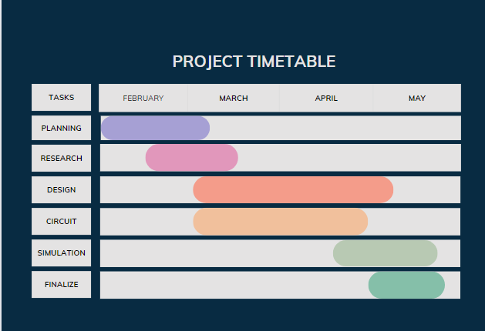

**Figure 1: Project Timetable**

This chart explains our thought process and how we spent our time in making this project a success. We started this semester in February and finished our work until the submission of our final project.

# **Chapter IV**

# **Project Design**

## **System/Block diagram**

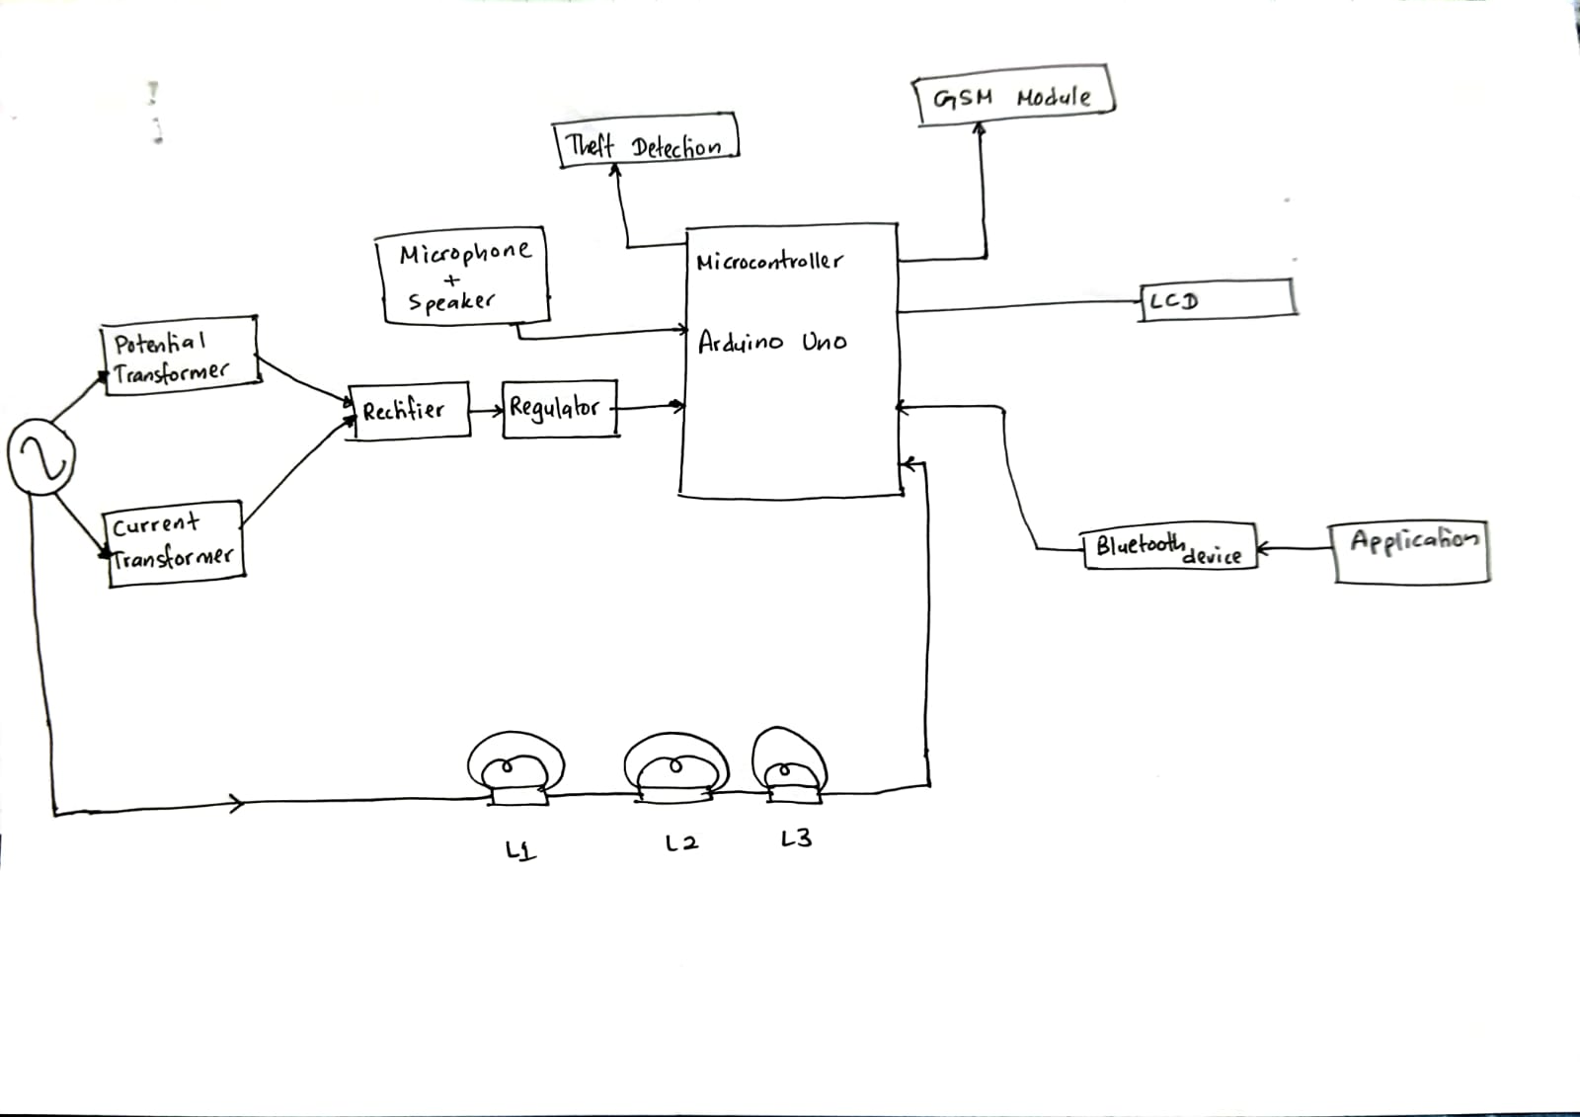

**Figure 2: Block Diagram**

The figure above is the block diagram of our project. We will have voice recognition, an app and SMS features.

## **Schematic diagram**

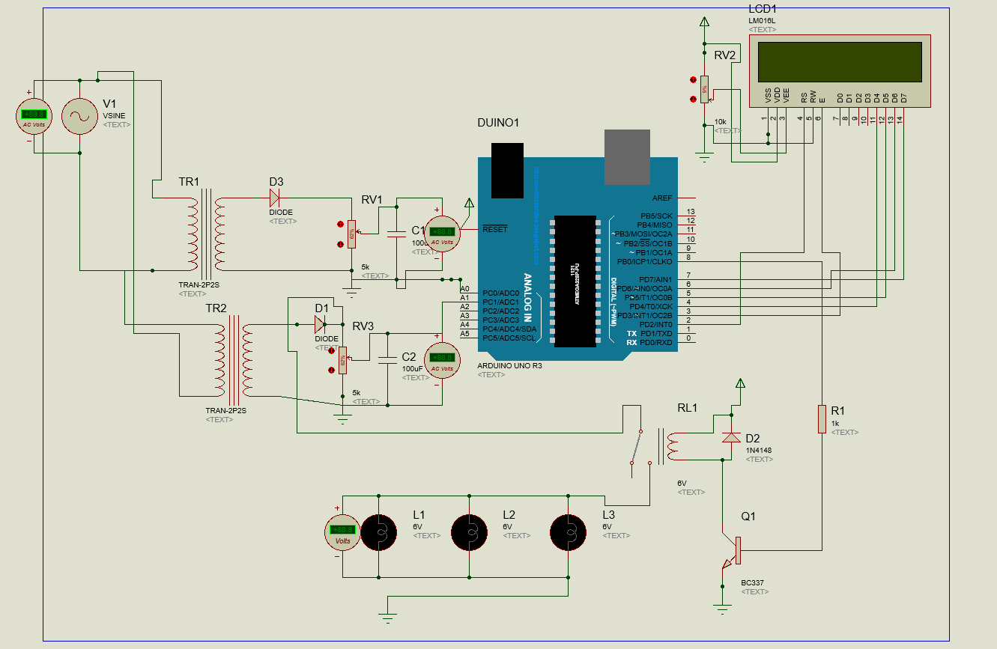

**Figure 3: Schematic Diagram**

Above is the schematic diagram for our project. In this, it is explained how our circuit will function. We have used GSM module for SMS alerts, and we have only used lamps for a simple demo. However the final project in the future will contain all electronic appliances.

## **4.3 System Flowchart**

# 

**Figure 4: System Flowchart**

The above flowchart describes the working process of our project. First the power will be on and the user will be asked to input a budget. Once the budget is set, the electric appliances will be assigned a time that they will be switched on for. Once the budget is nearing end, an SMS will be sent to user to either add more budget or their appliances will be switched off. If no budget is added, the appliances will switch off otherwise the appliances will stay on.

# **Chapter V**

# **Simulation and Testing**

## **5.1 Functions of Major Components**

We have used many components in our projects to make our circuit work correctly. Here are the Majors Components that we used:

1. ESP32: very well-integrated with filters, power management modules, low-noise receive amplifier, power amplifier, RF balun, and built-in antenna switches. We have used ESP32 and not Raspberry Pi because Raspberry Pi could accomplish the same task as an ESP32, however it is not practicable due to the expense and dimensions of each. The ESP32 is a Wi-Fi/Bluetooth enabled microcontroller with sufficient computing capability to tackle Internet of Things activities, bridging the gap between the Arduino and Raspberry Pi.

2. Arduino Uno R3: is the greatest board for learning how to code and work with electronics. The UNO is the most durable board you can begin experimenting with if this is your first time modifying the platform. Among the whole Arduino family, the UNO is the board that is used and documented the most. We have used Arduino Uno R3 and not Raspberry Pi because Projects requiring analogue inputs, such reading sensors or managing motors, are better suited for Arduino. Although Raspberry Pi can accept analogue inputs, it needs other parts, like an analogy-to-digital converter. Regarding to the cost, Raspberry Pi devices are somewhat more expensive than Arduino boards.

3. GSM (Global System for Mobile Communications) Module: refers to a specific type of gear that makes use of GSM technology to allow for communication over cellular networks. We used an GSM Module and not Wi-Fi Module because of their unique benefits. Unlike Wi-Fi, which depends on local access points, GSM modules provide greater coverage and dependability for communication over cellular networks. They are especially well-suited for applications involving remote monitoring and control in situations where Wi-Fi infrastructure could be erratic or absent. Furthermore, GSM modules allow for communication in places with spotty or non-existent internet access, which makes them perfect for Internet of Things devices placed in distant areas or mobile systems that need constant contact. Although Wi-Fi modules can provide reduced latency and greater data rates in some situations, GSM modules are favoured because to their widespread coverage and resilience across a range of IoT and M2M applications.

5.Sound Sensor- We will be using Arduino coding with the sound sensor/mic to use the voice recognition feature in our project to turn on and turn off lights.

## **5.2 Functional Simulation**

We want our project to help people save money and the environment by reducing the use of electricity. As a result, here is how our SEMS project will operate: All of this will be linked in an application that lets you control the devices and see which devices have reached which limit. The devices to be defined will be linked to a Bluetooth connection to the person's device, allowing the arrival of SMS messages to know the price of the bill and other things like the status of the amount of device consumption by setting a limit for each device.

## **5.3 Actual Functional Test**

When you switch on our circuit, the AC current will flow through and transformers will reduce the voltage and then using the rectifier we will rectify the voltage. You will need to add your budget through SMS and then the LCD and Blynk app will show how much power is being used by the lamps. When the limit is close to reaching, an SMS will be sent by the circuit to the user. And another message will be sent when the budget is reached. The lamps will switch off until the budget is increased. The voice recognition can be used to switch on and off the lamps. The Blynk app can show how much power each lamp/ electrical device used.

## **5.4 Tabulation of actual and simulated outputs**

|  |  |
| --- | --- |
| **Simulated Output** | **Actual Output** |
| Can change limit or budget through app | Can change the limit/budget through SMS only |
| Create our own application | We used Blynk IoT app due to lack of knowledge |
| Use voice recognition to change budget | Can use voice recognition only to control devices |

# **Chapter VI**

# **Results and Discussion**

## **6.1 Findings**

1.User Engagement: The addition of voice recognition, apps, and SMS capabilities has greatly raised user interaction with the electricity management system. Interacting with the system via a variety of channels is convenient and accessible, which is valued by users.   
  
 2. Ease of Use: Users can now monitor and regulate their electricity usage more easily thanks to the integration of speech recognition, apps, and SMS functions. Using voice commands and user-friendly interfaces has made controlling energy use easier.   
  
 3. Real-time Monitoring: Users may receive real-time reports on their energy usage through the system's SMS alerts, app notifications, and voice commands. This allows them to make quick modifications to maximize efficiency and cut expenses.

4. Personalization: Personalized energy management advice based on user preferences and behavior patterns are now possible thanks to the app and speech recognition technologies. Users have been able to better fit their specific needs with their energy-saving tactics.  
  
 5. Accessibility: A larger spectrum of customers, including those who might not be tech-savvy or have restricted access to cellphones or the internet, can now utilize the electricity management system thanks to its SMS, app, and voice recognition features.

## **6.2 Graphical representation of results**

**Figure 5: Graph of Results**

Above is a graph for Comparison of money spent each month made using the data collected from a survey of one family of 6, who have used S.E.M.S for 6 months for controlling their electricity and have also provided us with data of 6 months before using S.E.M.S.

## **6.3 Analysis of the results and discussion of findings**

The analysis of results from the smart electricity management system project with SMS, app, and voice recognition features reveals several key findings that have significant implications for energy efficiency and user experience.

1. Reduction in Energy Consumption: The data indicates a discernible drop in energy consumption following system installation. Through voice commands, app notifications, and SMS alerts, users were able to more efficiently monitor their consumption, which resulted in more energy-saving

2. User Engagement and contentment: More user engagement and contentment have been attained as a result of the incorporation of various communication channels, including SMS, apps, and voice recognition technologies. Users had a more pleasant experience because of how easy and accessible it was to interact with the system in different ways.

3. Benefits of Real-time Monitoring: Users have found the system's real-time monitoring features to be quite helpful. Users now have the power to take charge of their consumption patterns and make wise decisions to maximize efficiency thanks to the ability to receive real-time reports on energy usage and make modifications immediately.

4. Personalized suggestions: Users have expressed a positive opinion of the voice recognition and app-generated personalized energy management suggestions. Customizing recommendations according to personal tastes and habits has enabled users to adopt more efficient energy-saving techniques that meet their unique requirements.

5. Accessibility and Inclusivity: The speech recognition, app, and SMS features have improved the power management system's accessibility and inclusivity for a larger user base. Irrespective of technical expertise, all users may now interact with and take advantage of the system more easily thanks to its voice commands and user-friendly interfaces.

# **Chapter VII**

# **Conclusion and Recommendation**

## **7.1 Conclusion**

In conclusion, this project was able to help people set a budget or limit for their monthly electricity bill in order to save their money. This project also helps in conserve energy by using electricity only as much as needed. It has improved for the user in terms of user convenience and energy efficiency with the usage of SMS and app features in a smart electricity management system. Better energy management practices result from customers being able to quickly monitor and adjust their electricity consumption in real-time through the integration of SMS notifications and an intuitive smartphone interface.

Customers' power bills have decreased and energy saving has been encouraged by the system's capacity to offer individualized recommendations, timely notifications, and remote control capabilities. Furthermore, the whole user experience has been improved, making it easier and easier for users to connect with the system thanks to the flawless integration of SMS and app capabilities.

Overall, the smart electricity management system has demonstrated significant benefits in terms of energy savings, user engagement, and operational efficiency. As technology continues to advance, further enhancements and optimizations can be made to maximize the system's impact and contribute to a more sustainable and energy-efficient future.

## **7.2 Recommendation**

In order to improve this project, students can add features of the following:

1. Integration of Renewable Energy: Encouraging the integration of renewable energy sources, like wind turbines or solar panels, can help users monitor and optimize their usage and production of renewable energy.
2. Energy Usage Comparison: Encouraging users to lower their consumption and increase efficiency can be achieved by giving them the option to compare their energy usage with that of comparable homes or industry standards.
3. Appliance control: Allowing users to change the timings of how ling they will use each appliance through the app

# **References**

(Solarquarter, 2024) <https://www.mcreee.org/18688/>

(Energy Circle, 2024) -https://www.energycircle.com/smart-power-strips#:~:text=Smart%20power%20strips%20automatically%20turn,game%20consoles%20and%20so%20on

(Build with rise, 2022) <https://www.buildwithrise.com/research/energy-monitoring-systems>

(IEA, 2023) <https://www.iea.org/energy-system/energy-efficiency-and-demand/demand-response>

(How to Electronics, 2019) <https://how2electronics.com/iot-based-electricity-energy-meter-using-esp32-blynk/>

(Nevon Project, 2020) <https://nevonprojects.com/prepaid-energy-meter-with-theft-detection/>

# **Appendices**

|  |  |  |
| --- | --- | --- |
| Date/Day | Duration of meeting | Aim |
| (22/2/2024) – Thursday | 2 Hrs | We had our first meeting together and started discussing ideas for our project |
| (29/2/2024) – Thursday | 1Hr | We submitted our project idea for approval |
| (11/3/2024) – Monday | 1Hr 20min | Our project was approved |
| (14/3/2024) – Thursday | 40 min | We stated to design the application and creating the circuit. |
| (27/3/2024) – Wednesday | 1Hr | We started preparing for the Mid-Exam + We started to do the presentation and the poster for the Mid. |
| (1/4/2024) – Monday | 2Hr | We created the logo for the application. |
| (14/4/2024) – Sunday | 50min | We meet at the University Library to complete the last part of the presentation and the poster before the report. |
| (15/4/2024) – Monday | 2Hr | We had our first Online meeting before the presentation and distributed the slides between us + each one of us prepared a speech for the part of the presentation. |
| (17/4/2024) – Wednesday | 40min | Our Mid-Exam was conducted -online- during to the rain storm. |
| (18/4/2024) – Thursday | 2Hr | Mister Rashid posted on Teams the intern report and the submission day for it. |
| (22/4/2024) – Sunday | 1Hr | We submitted the report. Started preparing for finals |
| (25/4/2024) – Thursday | 1Hr 10min | Our supervisor discussed with us the with us the Final report and the Final Exam date. |
| (1/5/2024) – Wednesday | 2 Hr 30 min | We started to connect the circuit and testing it with the simulation. |
| (2/5/2024) – Thursday | 1Hr | Completing the last parts of connecting the circuit and finishing our Final Report. |

